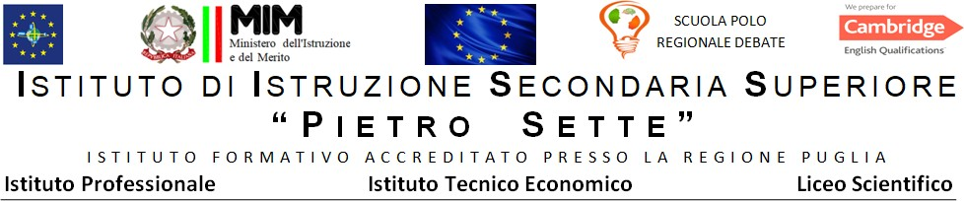

PROGRAMMA DISCIPLINARE DI Lingua e cultura inglese

Materia Inglese
Prof./ssa Gemmato Isabella
Classe V A LSSA
Libri di testo: Performer Shaping ideas vol 1 -2

ARGOMENTI SVOLTI
Shaping ideas vol.1
Gothic Fiction- Mary Shelley and Frankestein
ex The creation of a monster pag 270
Romanticism- All about William Wordsworth
ex. Daffodils pag.284
Shaping ideas vol.2
The early years of QueenVictoria'reign
The Victorian frame of mind
All about Charles Dickens
All about Oliver Twist
ex Oliver wants some more pag .29
Dickens and Verga
All about hard Times
ex The definition of a horse pag.35
ex. Coketown pag.38
The later years of Queen Victoria's reign
LateVictorian ideas
The late Victorian novel
All about Robert Louis Stevenson – Dr Jekyll and Mr Hyde
ex . The investigation of the mystery pag 106
ex. The scientist and the diabolical monster pag.108
Aestheticism
All about Oscar Wilde -The picture of Dorian Gray
ex I would give my soul pag.120
The Edwardian age
The modernist revolution
Freud's influence
A new concept of space and time
the modern novel
the interior monologue
All about James Joyce
All about Dubliners
ex Eveline pag.211
Finnegans wake -a photocopy
the Dystopian novel
All about George Orwell
All about Nineteen Eighty -Four
ex Big Brother is watching you
the absurd and anger in drama
All about Samuel Beckett
Waiting for Godot
ex Nothing to be done pag.342
International Organizations

PARTE DEL PROGRAMMA DA SVOLGERE DOPO IL 15 MAGGIO

Santeramo in Colle,10/05/2024

Il/la docente
Isabella Gemmato

